

King’s Trust achieve programme referral
Name of young person:
Young person’s date of birth:
Young person’s address:
Name and details of referrer:

Past/ current school:

Details of any current challenges including academically, behaviourally, mentally or physically?

Support the young person would require for engagement:

Any allergies/ medical conditions:

Emergency contact information:

Permission for photos to be used on social media: Yes/ No
Permission to provide first aid as required: Yes/ No
Permission to take young person off-site for activities: Yes/no
Preferable location for programme to take place (school, home, youth club etc):

Please circle the appropriate units on the attached table. This will form the units on offer, but further lessons may be offered on Weapons prevention, relationship and sex education and drugs and alcohol education if this is suitable. Please list here any objections to this.

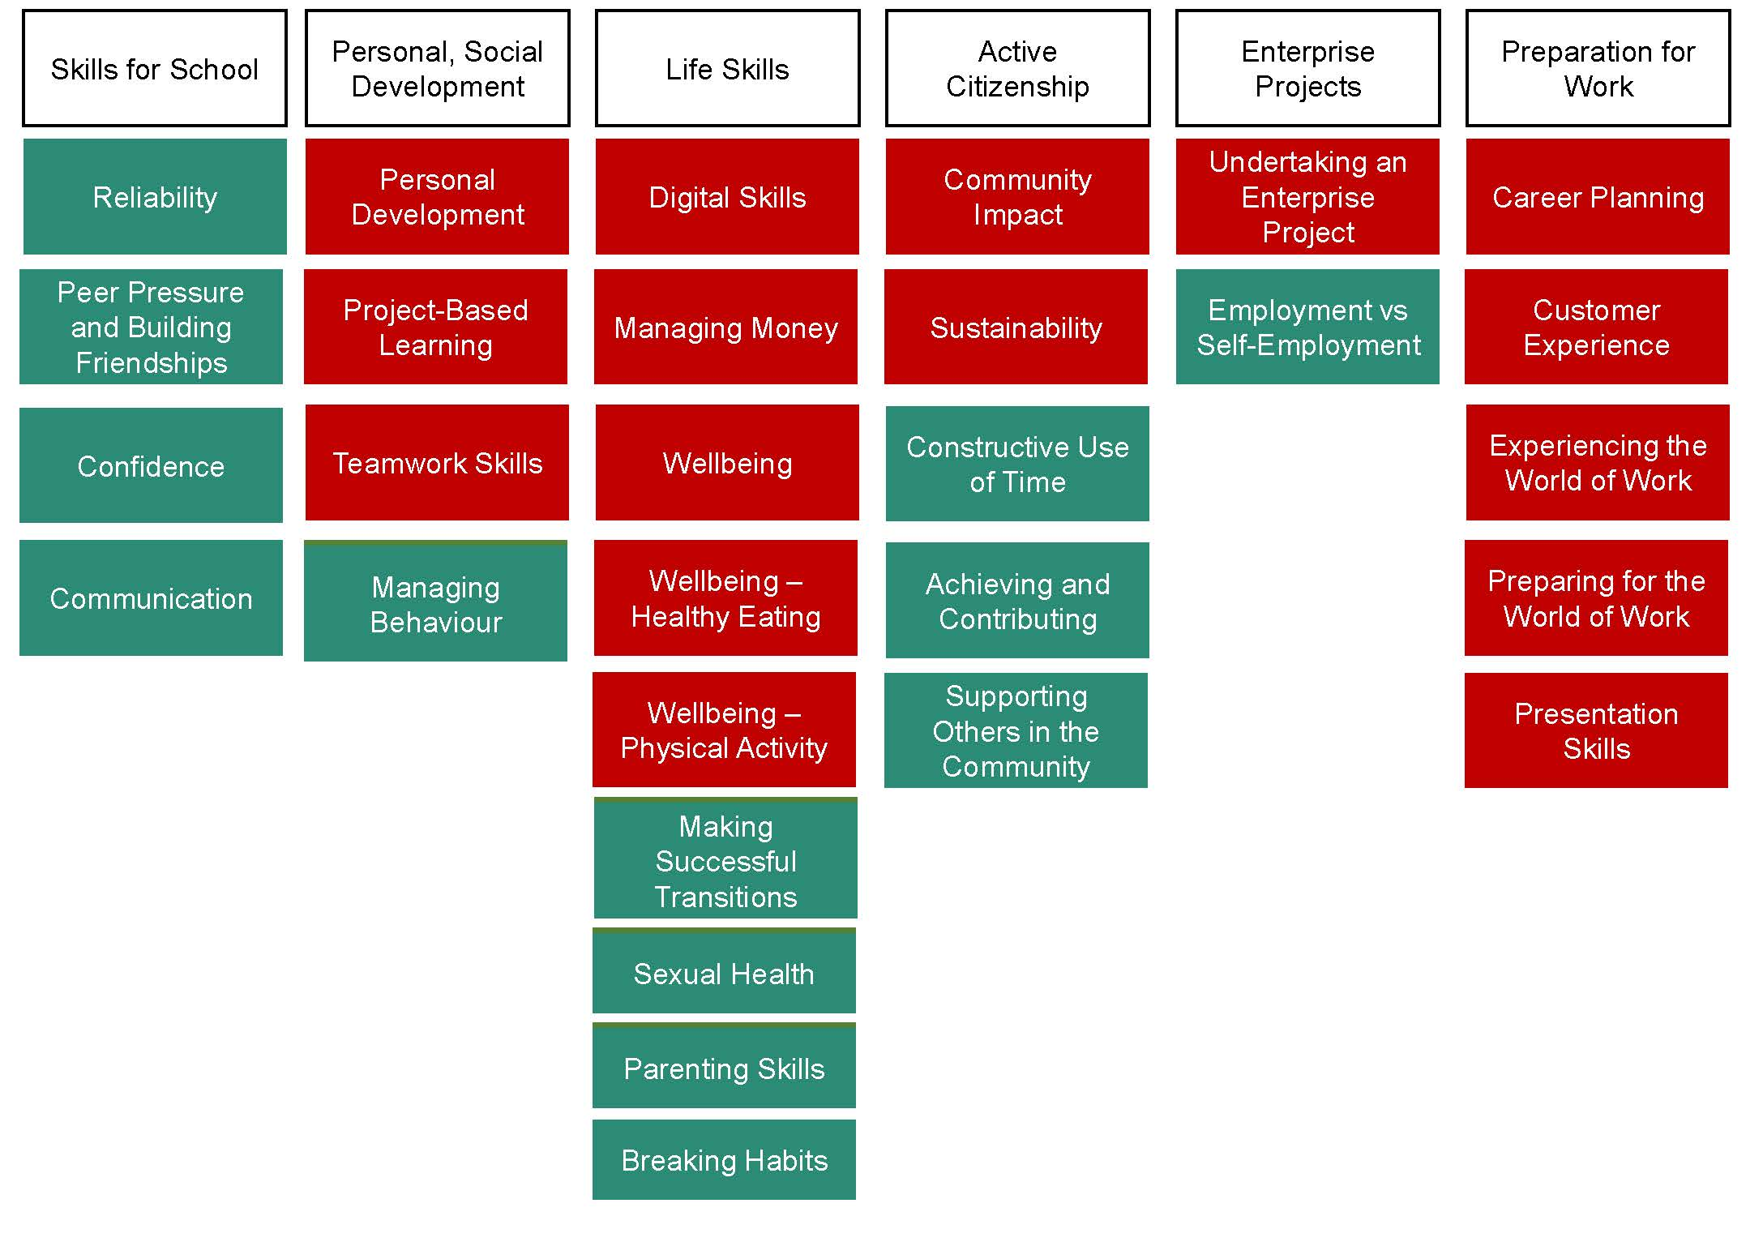

Signed –
Date -

